February 6, 2023

Senate Education Committee
Colorado General Assembly
200 E. Colfax Avenue
Denver, Co 80203

RE: SB23-099 Special Education Funding SUPPORT

Madame Chair and Members of the Senate Education Committee:

Thank you for accepting my testimony today.

My name is Dr. Kathleen Wilson and I am a Volunteer Lobbyist with the League of Women Voters of Colorado. The League is a nonpartisan organization that encourages informed and active participation and influences public policy through education and advocacy. Our membership spans the state of Colorado with 19 local leagues operating in several regions of the state. I am testifying today in support of SB23-099 on behalf of our state League’s Legislative Action Committee.

The League supports public education and public education funding in Colorado. We note that Colorado ranks 32rd in the US for education funding in general. In our view it is imperative that the Colorado General Assembly does all it can to create an adequate funding stream for PreK-12 Grade programs, including Special Education in our public schools.

The League supports a state finance system that provides enough funds for public schools to equalize educational opportunity. We believe the Colorado school finance system should include the following objectives:
• equity for students and school districts;
• adequate sources of revenue;
• support for high-cost programs for students with special needs.

Thank you for your consideration of this vital issue for Colorado students. We urge you to VOTE YES on SB23-099 Special Education Funding.

Sincerely,
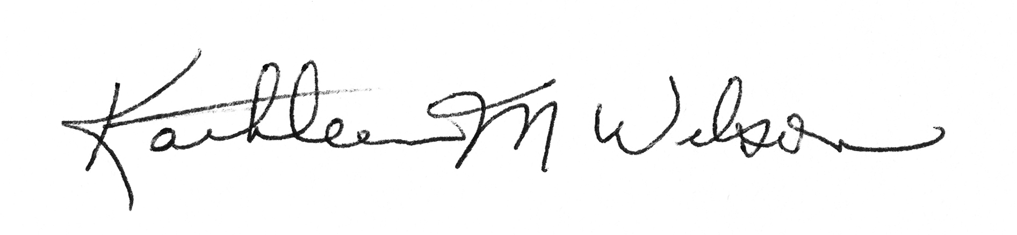
Kathleen M. Wilson, Ph.D.
Co-Director of Action & Advocacy
League of Women Voters of Colorado

